Lab-9

Queries and screenshot:

1. List the titles of all movies directed by ‘Hitchcock’.
2. Find the movie names where one or more actors acted in two or more movies.
3. List all actors who acted in a movie before 2000 and also in a movie after 2015 (use JOIN operation).
4. Find the title of movies and number of stars for each movie that has at least one rating and find the highest number of stars that movie received. Sort the result by movie title.
5. Update rating of all movies directed by ‘Steven Spielberg’ to 5.

**1.** select m.MOV_TITLE from MOVIES m,DIRECTOR d

where

d.DIR_NAME="Hitchcock" and

d.DIR_ID=M.DIR_ID;

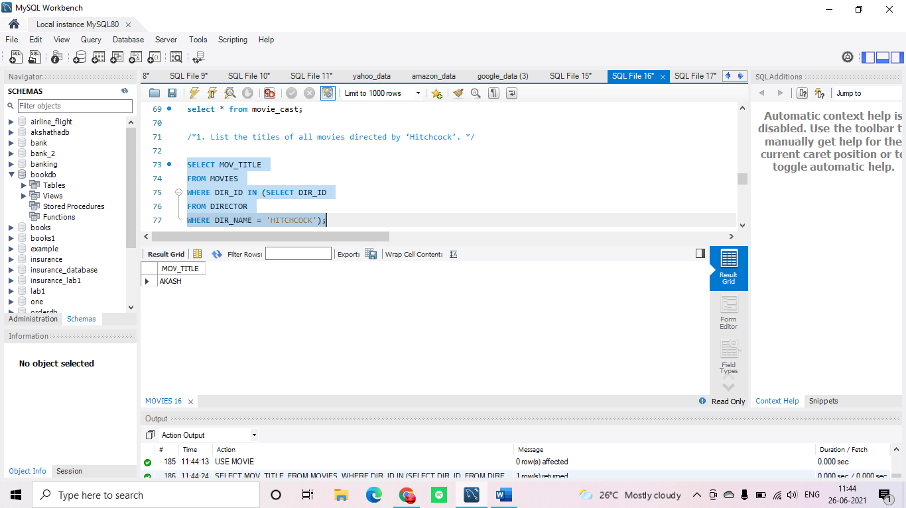

**2.** select m.MOV_TITLE from MOVIES m,MOVIE_CAST mc

where

mc.MOV_ID=m.MOV_ID and

mc.ACT_ID in (

select mc1.ACT_ID from MOVIE_CAST mc1

group by mc1.ACT_ID

having count(*)>=2)

group by m.MOV_TITLE

having count(*)>=1;

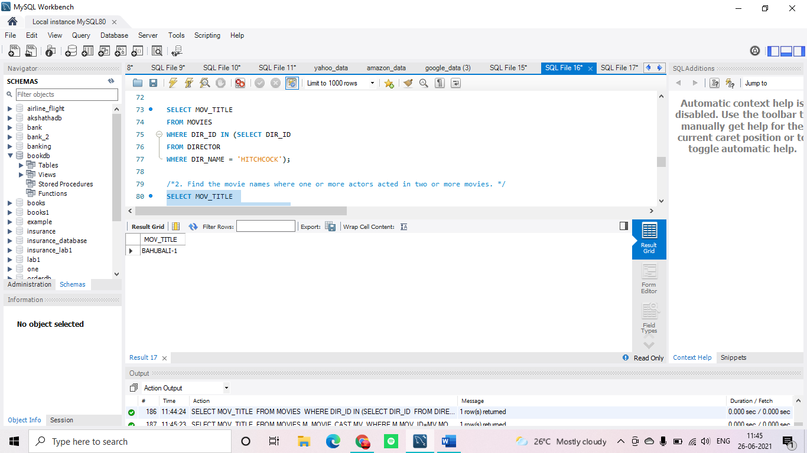

**3.** select a.ACT_NAME,m.MOV_TITLE,m.MOV_YEAR from ACTOR a

join MOVIE_CAST mc

on mc.ACT_ID =a.ACT_ID

join MOVIES m

on m.MOV_ID =mc.MOV_ID

where

m.MOV_YEAR not between 2000 and 2015

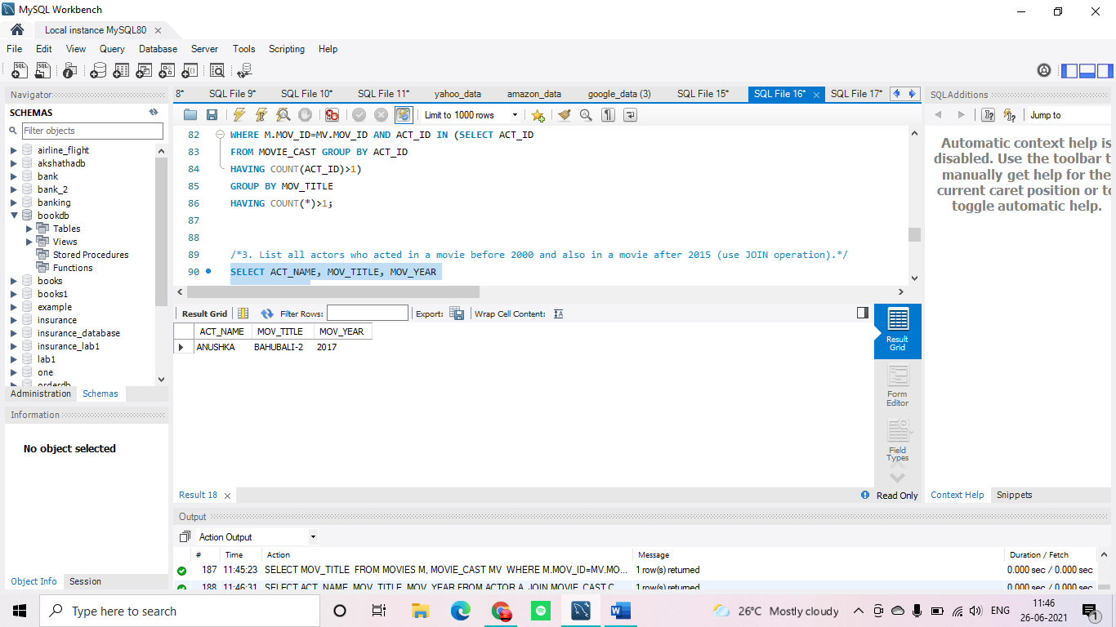

;

**4.** SELECT MOV_TITLE , MAX(REV_STARS) FROM MOVIES M,RATING R

WHERE M.MOV_ID=R.MOV_ID

group by M.MOV_ID

having COUNT(*)>=1

order by MOV_TITLE;

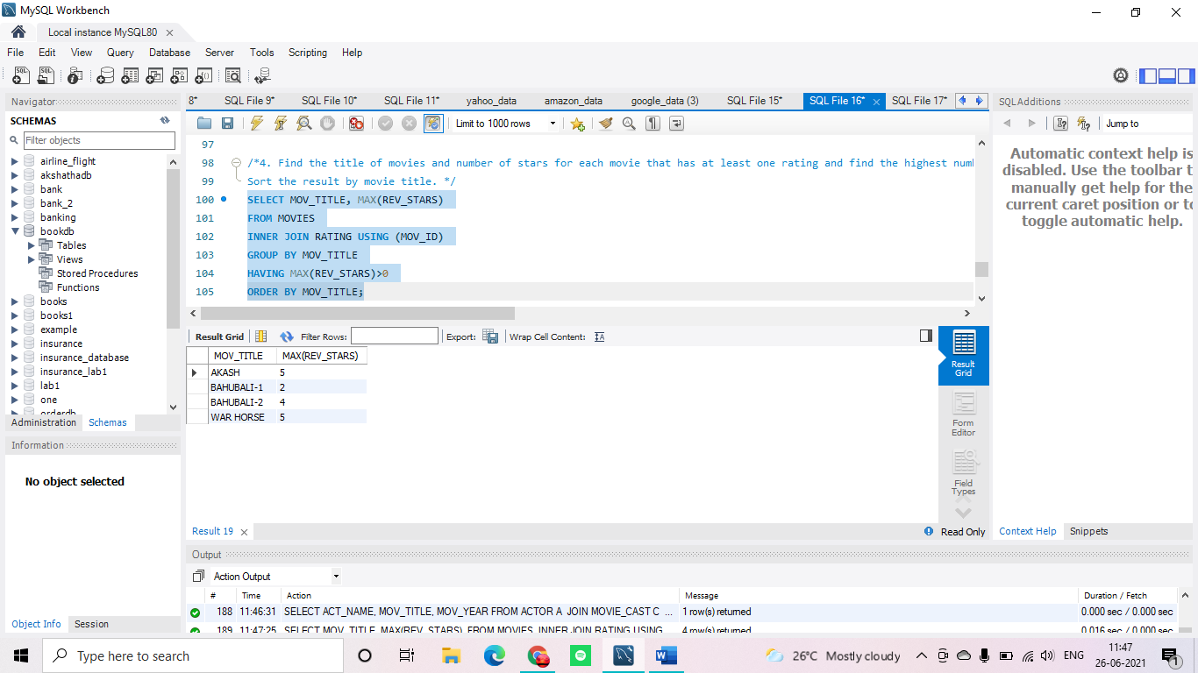

**5.** UPDATE RATING SET REV_STARS=5

WHERE MOV_ID IN (

SELECT MOV_ID FROM MOVIES

WHERE DIR_ID =(

SELECT DIR_ID FROM DIRECTOR

WHERE DIR_NAME="STEVEN SPIELBERG"

)

);

